Unit 6 Review

1. Calculate the energy of the violet light emitted by a hydrogen atom with a wavelength of 410.1 nm.

A) 4.85 × 10-19 J

B) 2.06 × 1019 J

C) 1.23 × 10-19 J

D) 8.13 × 10-19 J

E) 5.27 x 10-19 J

2. Calculate the wavelength of an electron (*m* = 9.11 × 10-28 -g) moving at 3.66 × 106 m/s.

A) 1.99 × 10-10 m

B) 5.03 × 10-10 m

C) 1.81 × 10-10 m

D) 5.52 × 10-9 m

E) 2.76 × 10-9 m

3. Which of the following colors of electromagnetic radiation has the shortest wavelength?

A) blue

B) violet

C) orange

D) green

E) yellow

4. How many orbitals are contained in the fourth shell (*n* = 4) of a given atom?

A) 1

B) 2

C) 9

D) 4

E) 16

5. What is the maximum number of d orbitals that are possible?

A) 1

B) 3

C) 7

D) 5

E) 9

6. Give the ground state electron configuration for Sr.

A) [Kr]5s24d2

B) [Kr]5s24d105p2

C) [Kr]5s2

D) [Kr]5s25d105p2

E) [Kr]5s24d10

7. Place the following in order of decreasing radius.

Te2⁻ F⁻ O2⁻

A) F⁻ > O2⁻ > Te2⁻

B) F⁻ > Te2⁻ > O2⁻

C) Te2⁻ > O2⁻ > F⁻

D) Te2⁻ > F⁻ > O2⁻

E) O2⁻ > F⁻ > Te2⁻

8. Give the ground state electron configuration for Se2⁻.

A) [Ar]4s23d104p4

B) [Ar]4s23d104p2

C) [Ar]4s24p6

D) [Ar]4s23d104p6

E) [Ar]4s23d84p6

9. Choose the valence orbital diagram that represents the ground state of Se2⁻.

A)

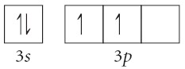

B)

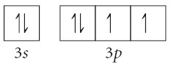

C)

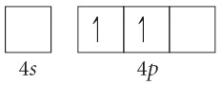

D)

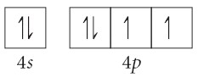

E)

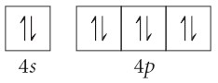

10. Calculate the energy of an electron in hydrogen moving from the 1st energy level to the 4th energy level.

11. In the above problem is energy absorbed or released.

12. A photon of light have the wavelength of 4.56 X 10-7m.

a. Calculate its energy

b. What is its frequency?